Practical 6 Arrays and ArrayLists
- Create an app class called ArrayListApp. Make an ArrayList that holds a bunch of names.
  - Add into the list the names of 5 family members.
  - Print to the screen
  - Delete one of the family
  - Print to the screen one family member per line- use a “for each”
  - Find the position of one of the family members
  - Print out the person in position 3
- Create a Balloon class
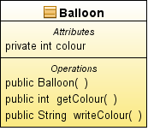

In the constructor fill up the colour data property with a random number between 1 and 10. The write colour method contains a switch statement that assigns a written colour for each colour number, i.e. 1 might be red, 2 blue etc.

In the main method of your App class create an array list containing 10 Balloon objects, write a loop showing each balloon’s string colour.

- Create a RandomNumbers class that contains a data property that is an array
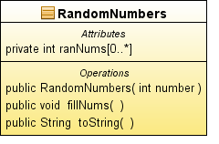
private int[] ranNums

The constructor accepts a parameter which is the size of the ranNums array, the array is created in the constructor. fillNums() fills the array with random numbers. toString() returns a String of all the numbers.
In the App class prompt the user for the array size, create a RandomNumbers object, fill it and print it to the screen.

